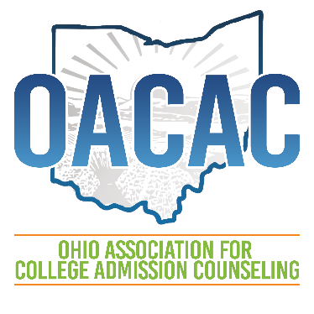
AGENDA
General Membership Meeting
December 16, 2020
3:00 p.m. – 4:00 p.m.
Via Zoom

Welcome and Call to Order, Collin Palmer, OACAC President

Announcements – How to make motions and vote during the meeting

- Call motion to approve agenda and minutes, Louisville, KY September ‘19

President’s Report
- Fall VCE overview – attendance & revenue
- Spring VCE
- Anti-Racism Training

Past-President’s Report, Kristen Dickerson
- Election and Awards nominations
- NACAC updates

President-Elect’s Report, Courtney Johnson-Benson
- Annual Conference 2021
- Annual Conference 2022
- SIG Update

Treasurer’s Report, Kayla Ritter Rickels
- Call for the Approval of the report

Bylaws Amendments, Tom Fanning, Governance Chair
- Proposed amendments and additions
- Call for motion to approve

Inclusion Access & Success, Marion Meadows, Chair

Unfinished Business
New Business
Motion to Adjourn

Next Meeting:

Tuesday, March 16, 2021 4:00 p.m. during virtual annual conference 2021

